Chapter 6: Terrestrial Worlds in the Inner Solar System

**6.1: Impacts Help Shape the Terrestrial Planets**

**Impacts and Craters**

* All terrestrial planets go through some level of tectonism, volcanism, impact cratering, and erosion
* Impact Cratering:
  + Process resulting from the collision of solid planetary bodies leaving impact craters
  + 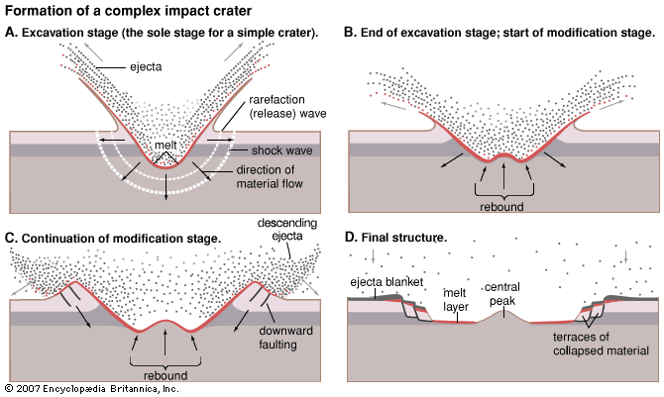Due to high orbital speeds, impacting craters release a huuuge amount of energy, causing some surface material to be “ejected” away from the impact sight
    - This debris sometime falls back to the planet, forming secondary craters
* The space rocks that cause these craters are referred to as:
  + *Meteoroids:*
    - Small (< 100 meters) cometary or asteroid fragments in space
  + *Meteor*
    - A meteoroid that enters and burns up in a planetary atmosphere
  + *Meteorite*
    - A meteoroid that survives entry to hit the ground
* Best preserved impact craters on Earth: Meteor Crater in Arizona
* A lot can be determined from impact craters
  + Martian impact craters indicate that Mar’s surface contained water/ice at some point
  + The age of a surface can be determined through cratering as well

**Calibrating a Cosmic Clock**

* # of visible craters is determined by the rate at which they are destroyed
  + This is determined by the geological activity of the surface
  + The moon’s craters are all relatively completely intact due to no geological change
* The # of craters can be used as a clock to measure the relative age of a surface
  + To calibrate this clock, you must look at the rate of decay of radioactive elements in the surface material
  + This is called *radiometric dating*
* The moon missions brought back samples and showed that the moon’s oldest craters were formed about 4.4 billion years ago, while the youngest surfaces were around 3.1 billion years
  + This is evidence that most cratering took place in the first 1 billion years of the solar system

**6.2: The Surfaces of Terrestrial Planets are affected by Processes in the Interior**

**Interior Composition**

* The composition of the Earth can be found in 2 ways:
  + Mass of Earth found using strength of Earth’s gravity
    - Dividing that mass by the volume gives the density (about 5,500 km/m^3)
    - Shows that the inner part of the Earth is denser than the surface, whose density is about 2,900 km/m^3
  + Could also look at meteorites, since they are made up of the same stuff as Earth

**Building a Model of Earth’s Interior**

* Earthquake-produced seismic waves are used to measure the composition of the Earth in order to create an accurate model of the inner part of the Earth
* 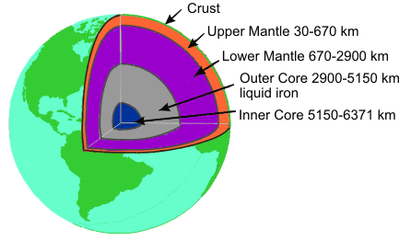Working from the center out:
  + 2 part core (iron, nickel, and other dense metals)
  + Mantle (medium-density materials)
  + Crust (thin, hard layer of lower-density materials
* Differentiation: the process of certain materials within planets to shift due to differing densities

**The Moon’s Structure and Formation**

* The moons core is composed of similar materials to the Earth’s mantle, lending to a theory of the moon having collided with the Earth during it’s formation

**The Evolution of Planetary Materials**

* The main factor determining the makeup of planets is its respective temperature, which changes due to the size of the planet, the composition of the material, and heating from various sources, among others
  + In general, the interior of a planet cools over time as heat is emitted from the surface
* *Cooling*
  + Planets emit radiation (heat), similar to how you feel heat through your hand over a hot stove.
    - Hotter the planet, more radiation energy emitted
    - Type depends on temperature of object (infrared, ultraviolet…)
  + Larger planets cool slower than smaller ones
* *Radioactive Heating*
  + Interior of planet is made of molten liquid and radioactive elements that radiates heat (left over from planet creation)
  + Equilibrium between radioactive heating of the interior and the loss of energy to space determines Earth’s interior temperature
* *Tidal Heating*
  + Tidal heating is essentially the pulling and stretching of the interiors of planets caused by changes in gravity through them that causes friction, heating the planet
    - Easily seen in the oceans, but also seen in the solid surface of Earth
  + *Lunar tides*
    - Pull by the moon stretching the earth
  + Solar tides
    - Pull by the sun stretching the Earth
  + Extreme tides
    - 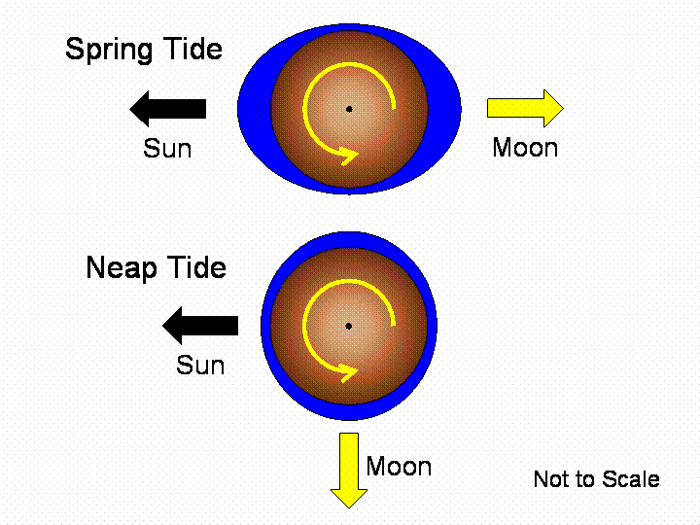When the moon/sun/earth are in a line (new/full moon), the effects are doubly seen. Called a *Spring tide.* (not related to the season)
    - When the moon is in 1st or 3rd quarter, there are *neap tides,* which are lower tides
* *The Effect of Temperature and Pressure on Material*
  + Pressure and temperature fight each other in the cores of planets
    - Outer core: temperature wins, thus molten
    - Inner core: pressure wins, thus solid

**Magnetic Field**

* Magnetic fields created by moving charges and exerts a force on magnetically reactive objects, such as iron
* Earth’s field created by rotation of planet and liquid magnetic core
  + 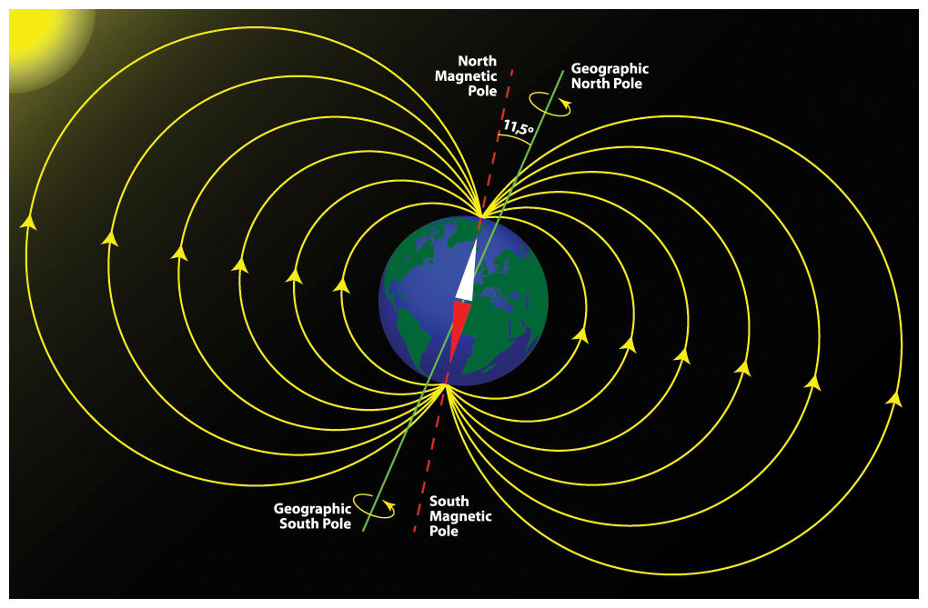Earth’s magnetic poles (not geographic poles) switch about every .5 million years
* Other than the Earth, Mercury is the only terrestrial planet with significant magnetic field today

**6.3: Planetary Surfaces Evolve through Tectonism**

**The Theory of Plate Tectonics**

* Plate tectonics: the theory that the continents were once one large continent that broke up and drifted apart
  + Perhaps the biggest advance in 20th century geology
* The Earth is made up of lithospheric plates that move about 15 centimeters a year

**The Role of Convection**

* 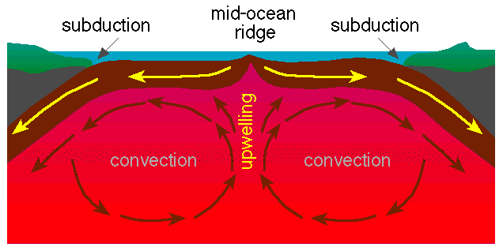Convection: the transport of thermal energy bu the movement of packets of gas or liquid
  + The main engine driving plate tectonics
  + Seen in ocean through convection currents which are “cells” of water that rotate from the bottom of the sea to the top continuously
* Faults: a fracture in a planet’s crust along which material can slide
  + Fault lines easily seen by looking at a map of earthquakes/volcanoes
* Hot spots: hot deep-mantle material rises, releasing thermal energy

**Tectonism on Other Planets**

* Mercury shrunk from its original size by about 5%, causing the crust to buckle and form faults across its surface
* Mars’s Valles Marineris is a 4,000 km is a chasm (about 4x the size of the Grand Canyon)
* Venus has a lot of volcanic activity and relatively few impact craters, suggesting it to be less than 1 billion years old
  + Venus is most similar to Earth of all of the planets in regards to size and mass, and its interior is similar to Earth’s in how it changes

**6.4: Volcanism Reveals a Geologically Active Planet**

**Terrestrial Volcanism is related to Tectonism**

* Volcanoes form when highly pressurized solid materials are forced to the surface through plate tectonics, causing the already hot materials to melt and then explode out
  + Shield volcano: lava flowing from a point surface evenly around
  + Composite volcano: forms when thick lava flows alternating with explosively generated rock deposits build a steep-sided structure
* Volcanoes often appear in chains (Hawaii)

**Volcanism in the Solar System**

* The moon’s marias (seas) are actually cooled volcanic rock, uncratered, suggesting volcanism after the period of heavy bombardment from meteorites
* Mercury also had volcanoes at some point
* Venus has more volcanoes than any other terrestrial planet
* 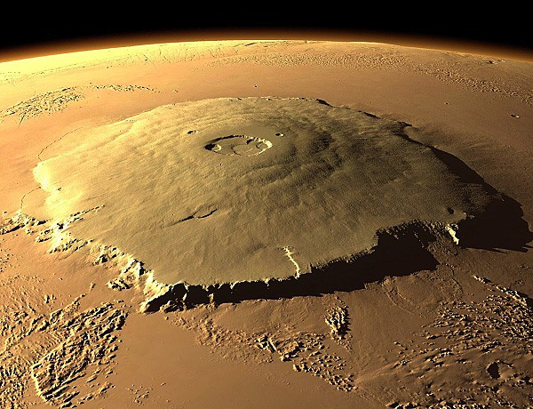Mars had volcanoes at some point, indicated by the fact that more than half of the surface of mars is covered by volcanic rock
  + Also has very large shield volcanoes (Olympus Mons)

**6.5: Wind and Water Modify Surfaces**

**Weathering**

* Normal weathering from wind and water are seen throughout the Earth
* Radiation from the sun and deep space also erodes materials, decomposing them very slowly
  + Very small changes (only a few millimeters), but is seen all throughout the solar system
* Impacts of micrometeoroids also cause weathering
* Landslides can also occur

**Wind Erosion**

* Earth, Mars, and Venus all show signs of wind erosion
  + Sand dunes on all that change
  + Wind vanes show the prevailing surface winds of planets

**Water Erosion**